Citizens on Patrol Program(COPP)

Eyes and ears of our community
There is more than one group patrolling the community to keep us safe. You may have seen the green vests downtown with the COPP logo in our Tri Community area. These people are the eyes and ears of the community, better know as the Citizens on Patrol Program (COPP).
The Citizens on Patrol Program began in Manitoba in 1991. Partnerships were formed between local law enforcement, Manitoba Justice and citizens who desired to make their communities safer. The Pas and area group originated in 1993 by RCMP Staff Sargent Dave Mancini. Three original members are currently active on the board since the beginning. They are Jim Blake, Wilf Lamontagne and Don Maksymchuk. The Manitoba Citizens on Patrol Program is overseen by a Provincial Advisory Committee which provides a forum for groups to share information and experiences.
Our mission is to mobilize citizens to participate in a community-based crime prevention initiative in co-operation with local law enforcement agencies. The three main goals of the program are:
1. Deterrence: to provide a presence in the community through patrolling by vehicle, by foot or by bicycle.
2. Education: to educate Manitobans about crime prevention
3. Awareness: to increase Manitobans awareness on crime related issues such as theft, vandalism and speeding.
Our group has taken on two other responsibilities: removal of graffiti from public property and cleaning refuse from the downtown core area.
However, the main goal of the Citizens on Patrol Program is to be on the lookout for any suspicious or criminal activity, to record this activity and where appropriate to report such activities to the police. COPP members act as additional “eyes and ears” for both their community and the police.
During the summer months, to protect children playing outdoors, we set up a speed reader board to caution drivers and create awareness to speed. We record the number of vehicles exceeding the speed limit and turn our results over to the authorities.
In past years COPP has acted in the roll of security for the local Trade Show, Street Festivals, Bill Bannock Fish Derby and for the Snowbird Air show.
Currently 26 volunteer members patrol areas in The Pas, Ralls Island, Carrot Valley, and Clearwater Lake. When patrolling on foot or bike, we do so with two members. When we are in a vehicle we patrol individually. It is up to each volunteer to determine when they want to patrol. The coordinator will arrange specific dates and times to encourage regular patrols. Normally, we meet the first Tuesday each month at the RCMP office at 6 p.m. Meetings are cancelled for July and August however members are still out on patrol and reporting their hours monthly.
Needless to say, the more members we can recruit the more patrols we can do. If you are interested in patrolling or having the speed reader board set up on your street please contact the Co-ordination, Paulette Aamot at 204 617-7659 or Judy Hoskins at 204 623-5736
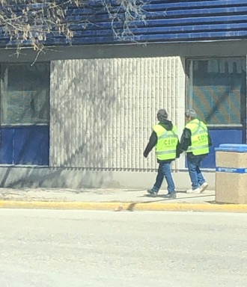
Paulette Aamot and Judy Hoskins patrolling the downtown core.

